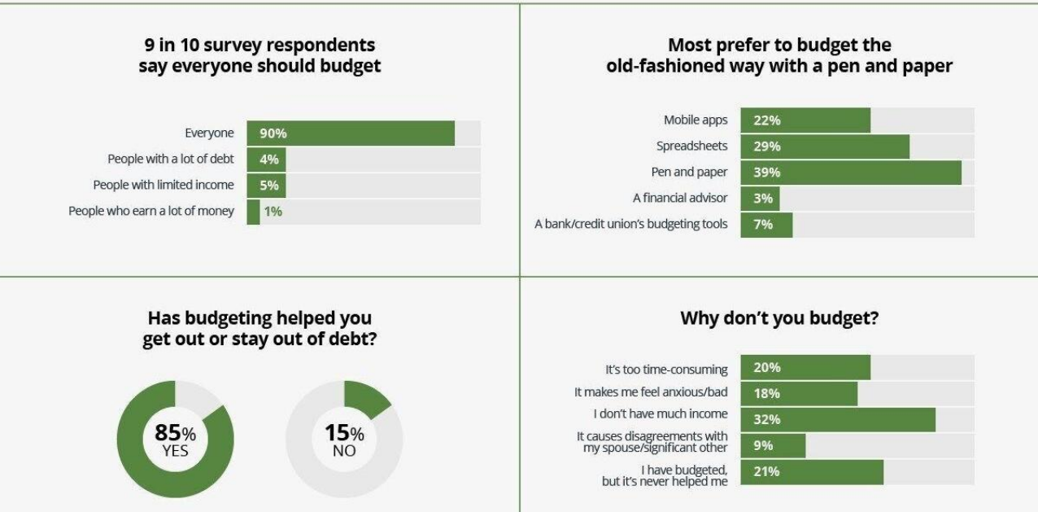

Resource Planning
- Importance
- Relationship to Schedule Planning
- Human Resources
- Other Resources
- After you have created the first draft of your schedule, an important step is to identify the resources required
- Sometimes the same resource is needed for two different tasks, so they cannot be carried out concurrently
- Resources include
  - Human resources
  - Other resources such as equipment, office space, computer hardware or software, construction materials

Relationship Between Schedule Planning and Resource Planning
- Based on the WBS, the PM and team have prepared the initial draft of the schedule
- This is a key step
- If you don’t yet understand the scheduling part of the planning process, review it before proceeding to resource planning

Estimating—tools and techniques
- Expert judgment
- Alternative analysis
- Published estimating data
- Project management software
- Bottom-up estimating

Resource Leveling
- If two or more concurrent activities need to use the same resources, the schedule may need to be adjusted
- If a very expensive piece of equipment such as a crane is required, the tasks may have to be rescheduled consecutively rather than concurrently
- This can also happen due to staff requirements
- Software such as MS Project has resource leveling tools

The mythical man-month
What is the impact of adding people to a project that is struggling to meet deadlines?

HR Planning
- The most important resource is the people
- Select the right people
  - Technically skilled
  - Motivated
- Provide them with the resources and training they need
- Nurture them—provide compensation and recognition
- Deal with issues promptly and as directly as possible

The person-day
- The work of one person for one day is a person-day
- You may also work with person-hours
- Think about how easy or difficult it is to substitute one person for ten days in place of ten people for one day on different tasks:
  - Installing ten dozen new PCs on desktops in an office area
  - Configuring the server which the PCs will use for file and print sharing
  - Creating a new computer game
  - Pouring a foundation
  - Building the forms into which the foundation will be poured

Typical project team roles
- Project Manager
- Developer
- Engineer
- Subject matter expert
- Team members
- Customer/client representative

The HR environment
- Laws
  - Employment regulations such as wage legislation, holidays
  - Health and Safety
- Culture
- Organizational standards
- Collective Agreements

Employee performance management
- Employee performance
  - employee’s work results such as quality or quantity of outputs,
  - work behaviour (such as punctuality)
  - job-related attributes (such as cooperation and initiative)
- After conducting employee performance reviews managers should:
  - provide feedback to employees about how well they have performed on established goals
  - provide feedback to employees about areas in which the subordinate is weak or could do better
  - take corrective action to address problems with employees performing at or below the minimum expectations
  - reward superior performers to encourage their continued excellence

Maslow’s Hierarchy of Needs
- Physiological
- Safety
- Love/belonging
- Esteem
- Self-actualization

Emotional Intelligence
- Self-awareness
- Self-regulation
- Empathy
- Relationship management

Personality Types
- Myers-Briggs: four dimensions:
  - Extroversion <–> Introversion
  - Sensing <–> Intuition
  - Thinking <–> Feeling
  - Judging <–> Perceiving
- Sixteen personality types can be derived from the four dimensions
- Generally, a MIX of personality types on a project brings strength
- Knowing your own type and the types of other team members can help people work together

Dimensions of Leadership
- Robert Tannenbaum and Warren Schmidt - leaders are either autocratic or democratic
- Harold Leavitt - leaders are pathfinders (visionaries), problem solvers (analytical), or implementers (team-oriented)
- James MacGregor Burns - leaders are either transactional (focused on actions and decisions) or transformational (focused on the long-term needs of the group and organization)
- Fred Fiedler - contingency theory, the ability of leaders to adapt

Negotiation
- A key project management skill
- Frequently, PMs have accountability but may have limited authority
  - Matrix management structure
  - Subject matter experts
- Negotiating with
  - Other managers
  - Suppliers
  - Customers
  - Others

Conflict
- Conflict is not a bad thing—it can be healthy for people to be able to express differences about how to approach the work
- Conflict-resolution styles:
  - Avoiding
  - Forcing
  - Collaborating
  - Compromising
  - Accommodating
Delegation
- PM is not expected to DO all the work
- Must identify and clearly assign work to others on the team
- Make expectations clear
- Recognize performance
- Follow through

Resource management techniques
Resource levelling
- The objective is 100% utilization
- Software can help

Resource Planning Summary
- Planning for resource utilization is a key process in preparing a project plan
- Resource planning follows the first draft of the schedule and impacts the schedule
- Resources include human resources and other resources
- Managing human resources includes hiring, training, motivating, rewarding
- A number of models can be used to help the team work together
- There are several theories of leadership; leadership is more than issuing directives

